Prehistoric tomb surveying


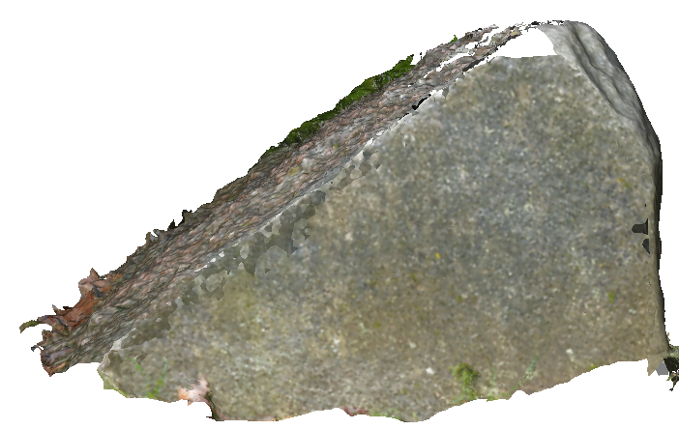
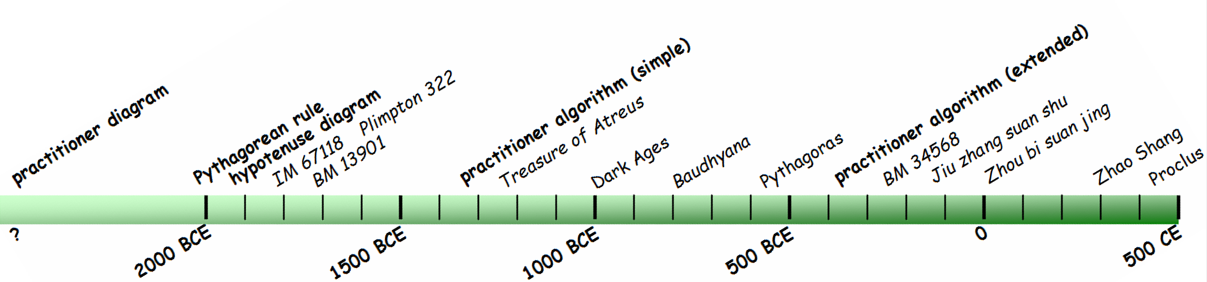
Prehistoric tomb surveying
Dirk Kruithof, September 2019

Introduction
Prehistoric tomb surveying (PTS) is a series of papers in which Neolithic and Bronze Age surveying is investigated in the light of geometry. Have the megalithic tombs simply been fitted together according to a habitual style like for example the pottery they contain or have they been designed according to some geometrical practise? The latter seems to be true, since the design of the tombs involved can be grasped by what is called a grid-of-squares geometry in the PTS-papers. The main result of this practise is known as the ‘Pythagorean triangle’ nowadays, since the Pythagorean Theorem lies at the basis. Neolithic surveyors were not used to theorems. Nevertheless, with the grid-of-squares geometry they knew how to construct ‘Pythagorean’ triangles 3000 years before Pythagoras lived. In the PTS-papers this construction is called practitioner diagram as displayed on the stone of the front page .
The PTS-papers concern both the geometrical and the archaeological aspects of the tombs. First a general overview of the subject is given (PTS-1), then the practitioner diagram is associated with the earliest written math problems (PTS-2). There even seems to exist an early ‘guide’ for the construction of the practitioner diagram (PTS-3). Finally, the geometrical features of the tombs themselves get through. PTS-4 relates the geometrical setups of some small Dutch hunebedden to the archaeological understanding of their construction. Since the application of the practitioner diagram gives the small hunebedden some dolmen-like characteristics, PTS-5 proposes for the new term ‘pseudo-dolmen’. The other papers show a carrousel of geometrical setups, ever by the same rules of the grid-of-squares geometry: PTS-6 about the entrances of Dutch hunebedden, PTS-7 about some dolmens along the Baltic coasts in Germany, PTS-8 about some Causse-type dolmens in the French Ardèche, PTS-9 about the entrances (stomions) of the Mycenaean tholos tombs and PTS-10 about the mounds of German megalithic tombs. The grid-of-squares geometry happens to be applied to all aspects of megalithic building for a long time.

Contents Page in the PDF
PTS (1) - Between geometry and happen chance 3
PTS (2) - Links to the earliest mathematical texts 17
PTS (3) - The 'Zhou bi suan jing' section #A3 31
PTS (4) - Mutual orientations between megalithic tombs 37
PTS (5) - Small hunebedden or pseudo-dolmens 61
PTS (6) - The entrances of Dutch hunebedden 67
PTS (7) - Dolmens along the German Baltic coasts 79
PTS (8) - Small necropolises in the French Ardèche 87
PTS (9) - Mycenaean tholos tombs 91
PTS (10) - Typification of Neolithic tomb mounds in Germany 108
PTS – Bibliography 124

